Results of NAVTTC Tasks Quizzes

- TASK 15 (For Loops):

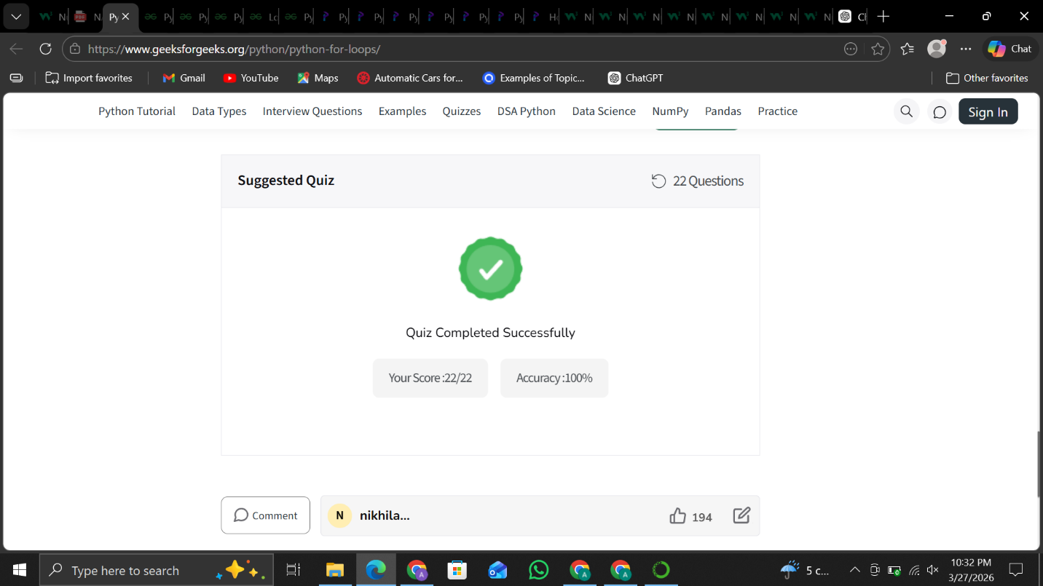

- TASK 16 (Python While Loops):

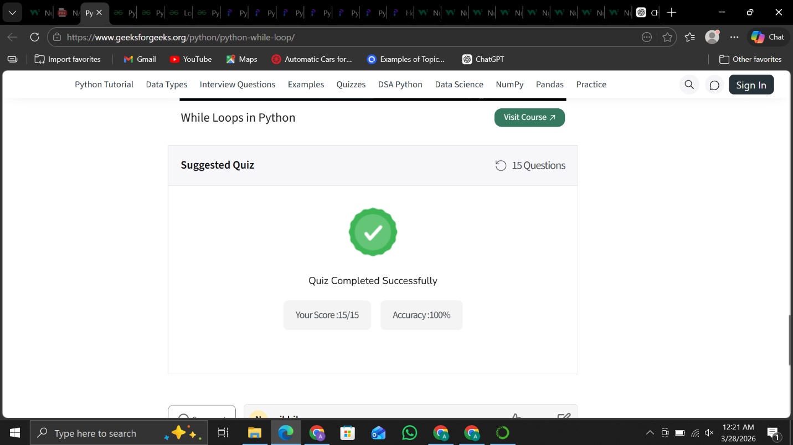

- TASK 20 (Python Functions):

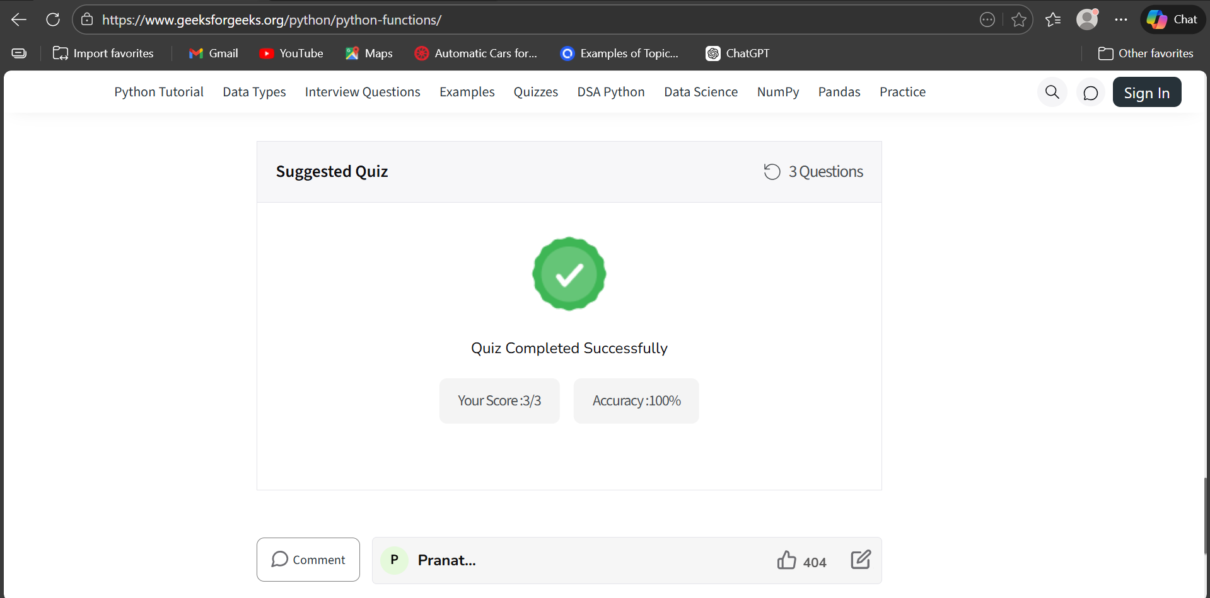

- Task 28 (Creating Arrays):

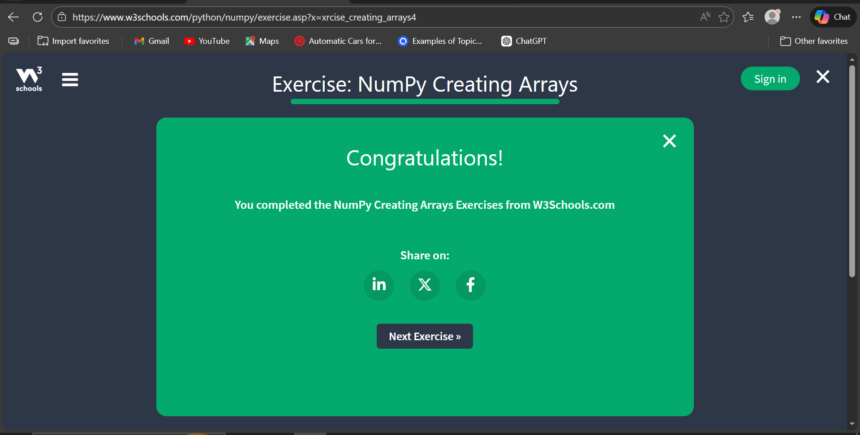

- Task 29 (NumPy Aarray Indexing)

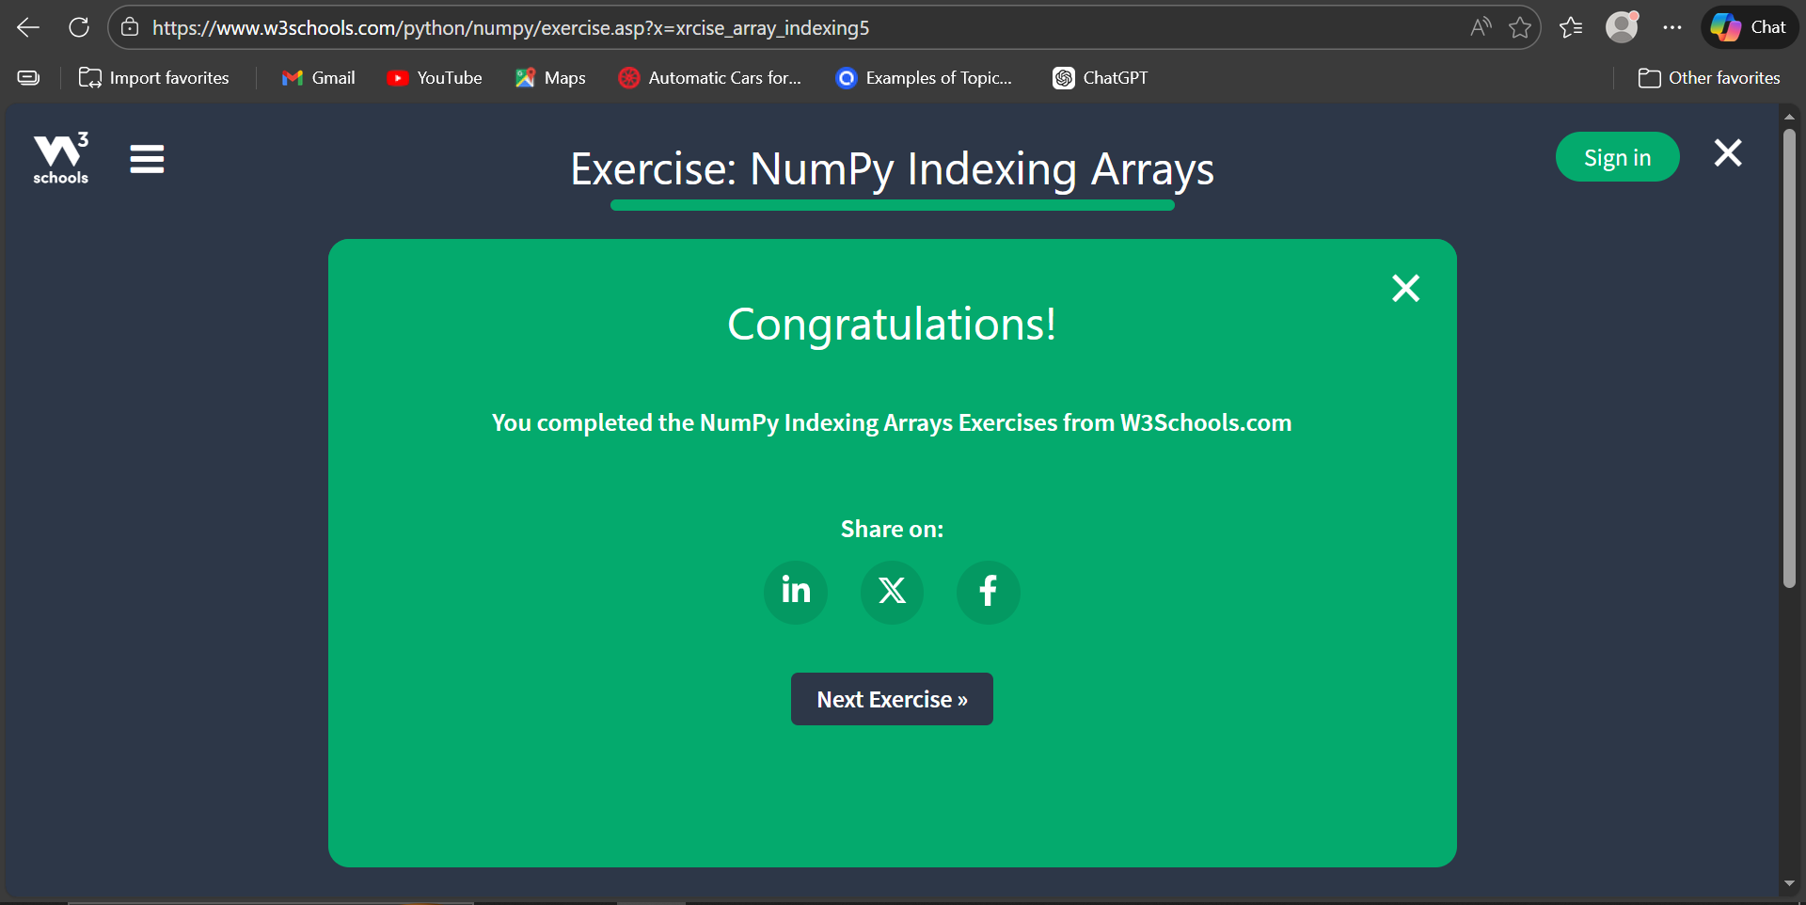

- Task 30 (NumPy Array Slicing):

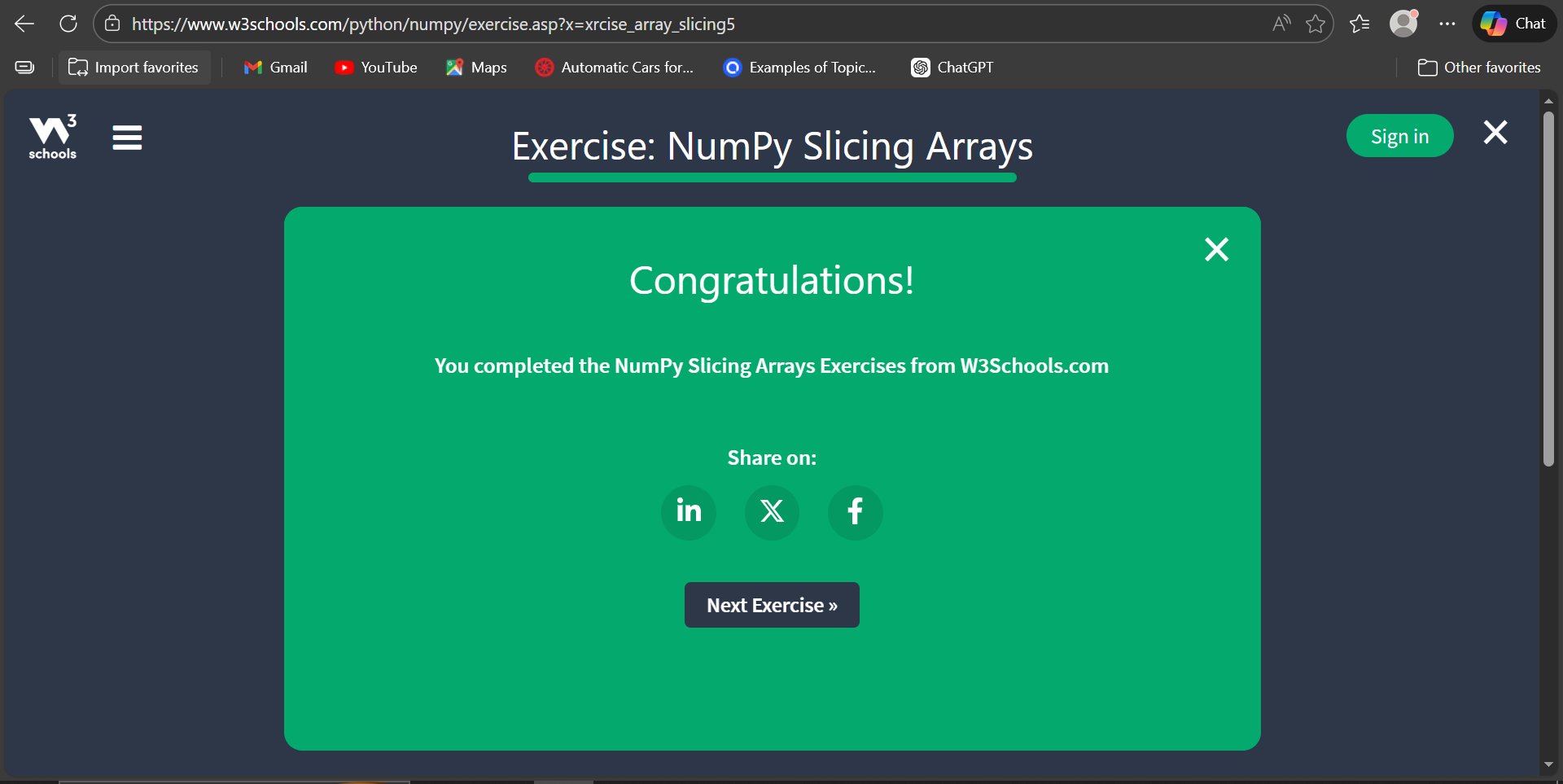

- Task 31 (Array Data Types):

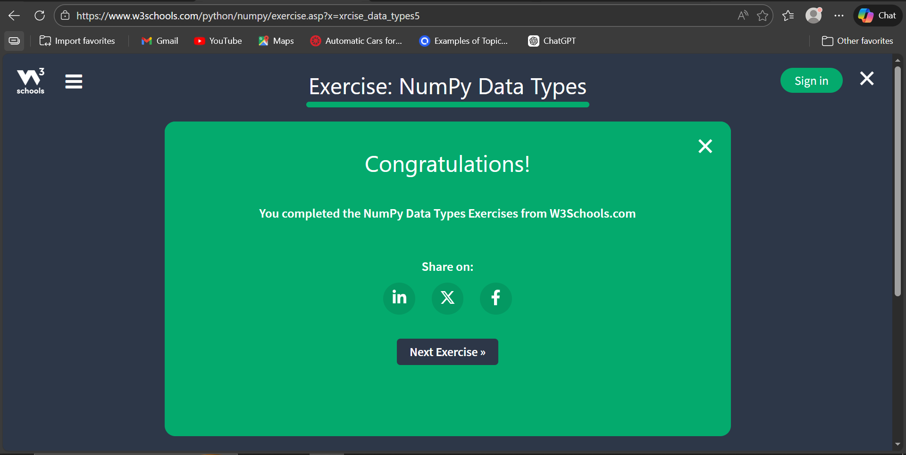

- Task 32 (Array Copy vs View):

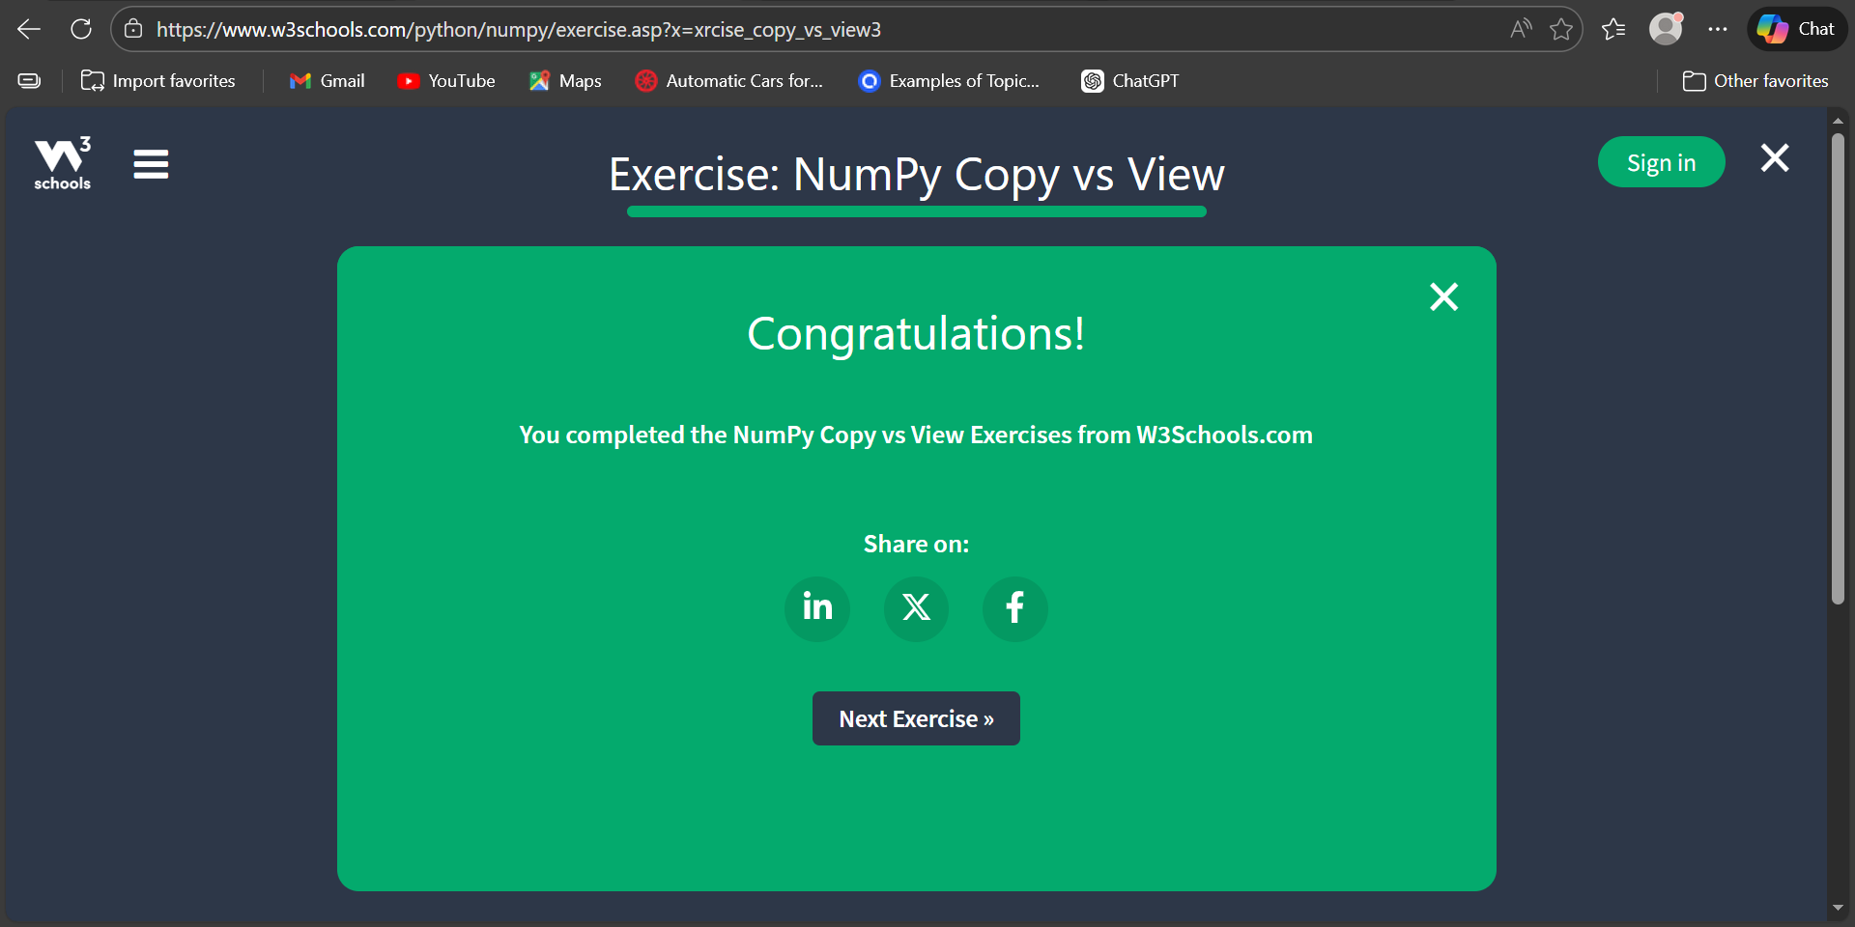

- Task 33 (NumPy Array Shape):

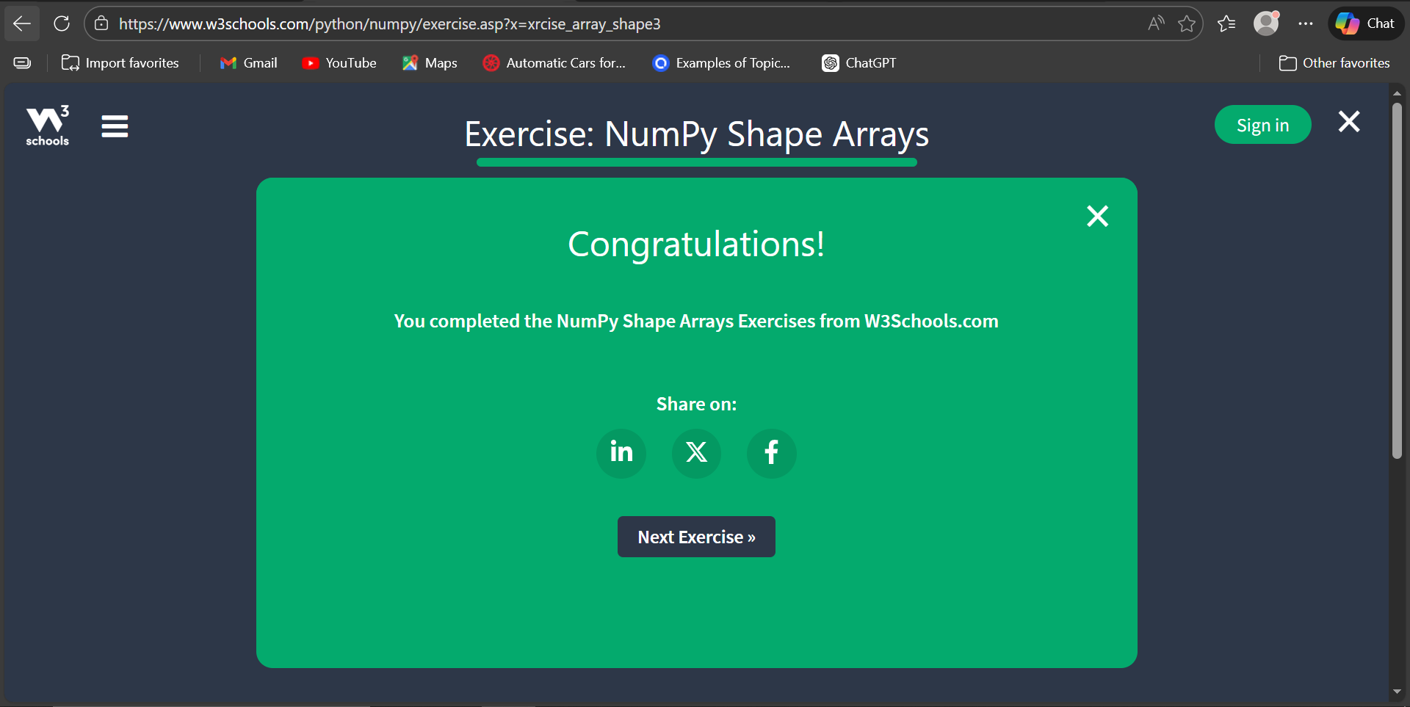

- Task 34 (NumPy Reshape Array):

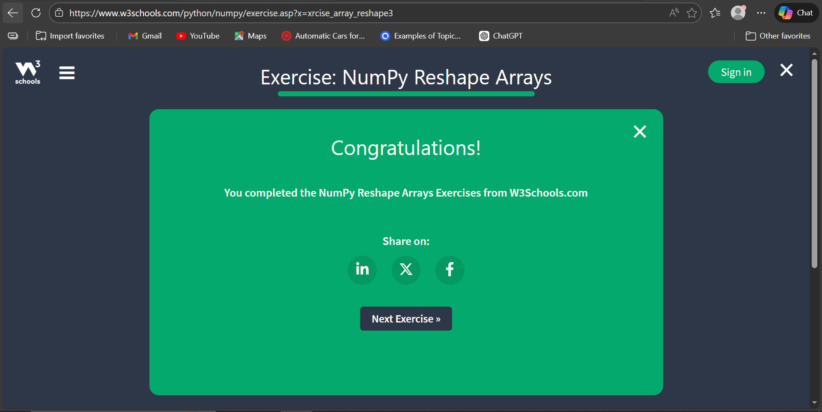

- Task 46 (Analyzing DataFrames):

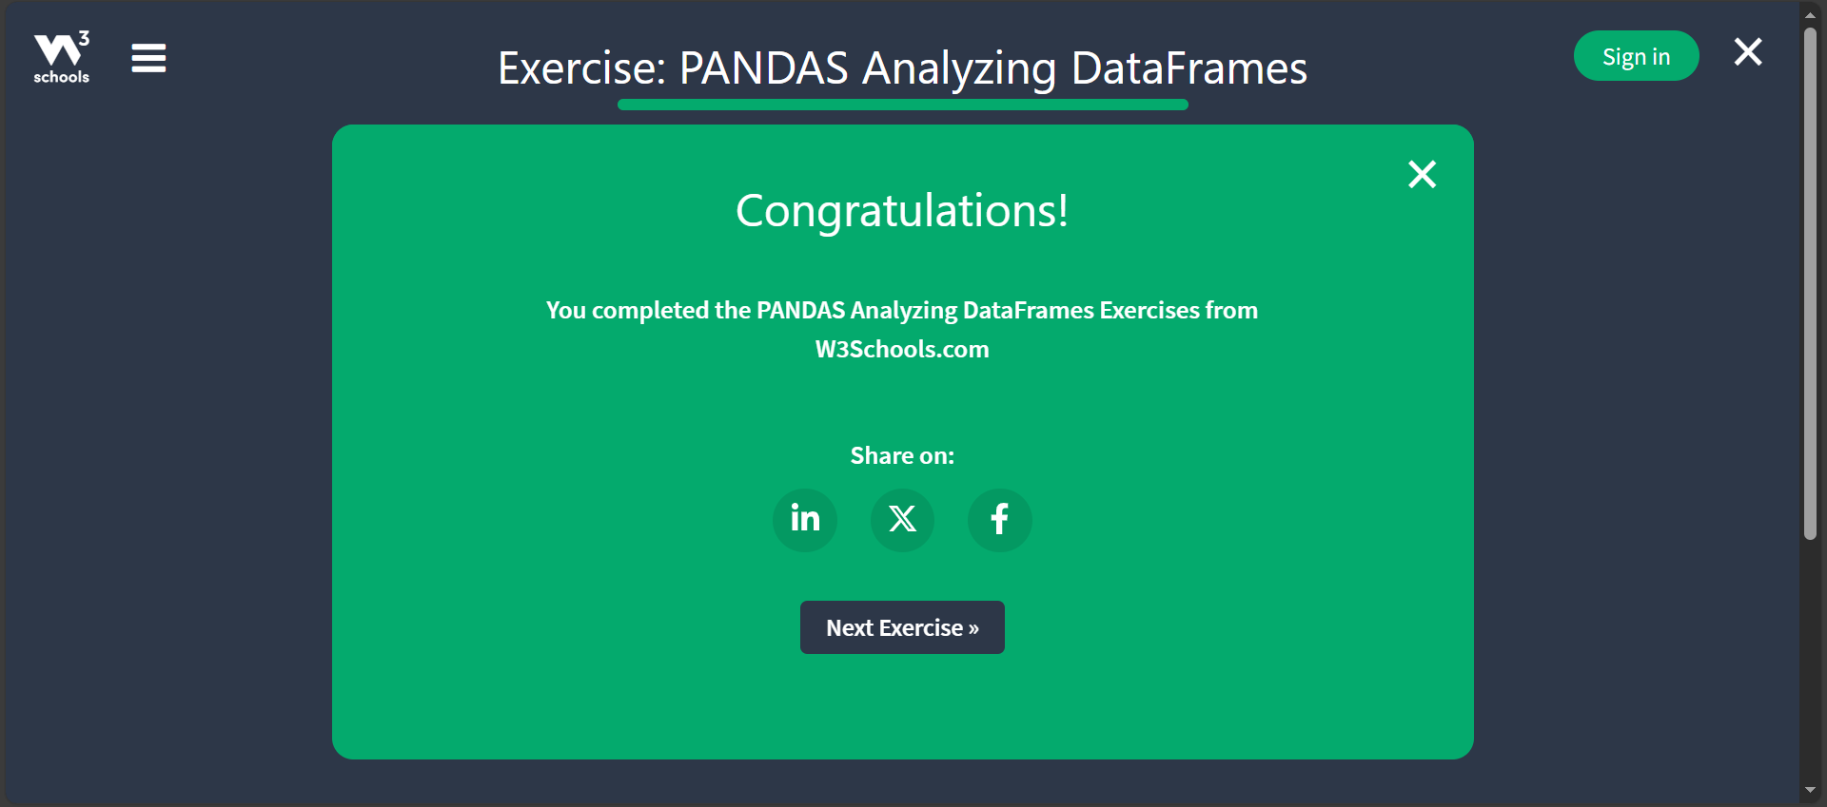

- Task 35 (NumPy Iteration Arrays):

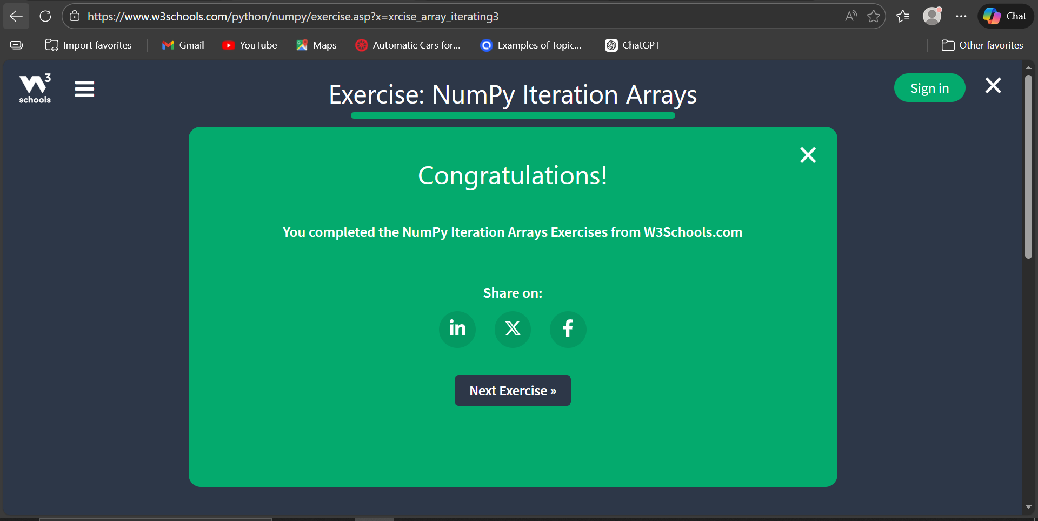

- Task 37 (NumPy Splitting Arrays):

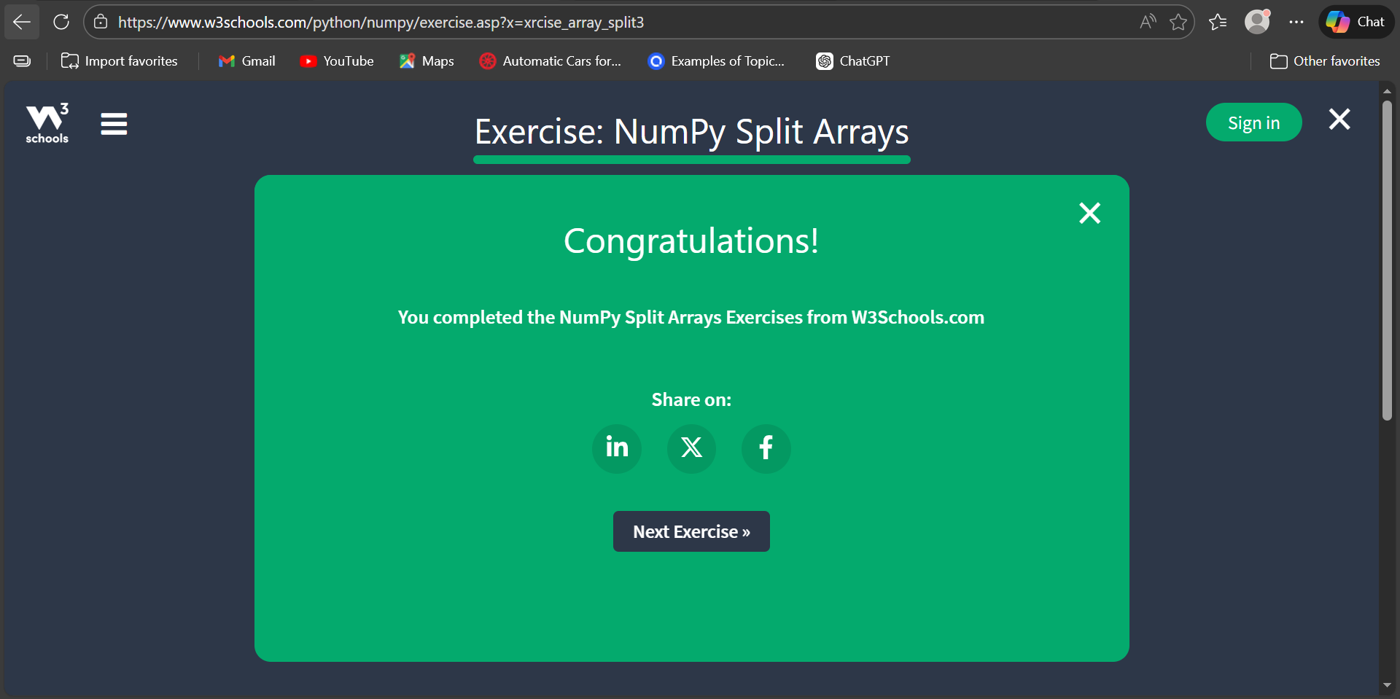

- Task 38 (NumPy Search Arrays):

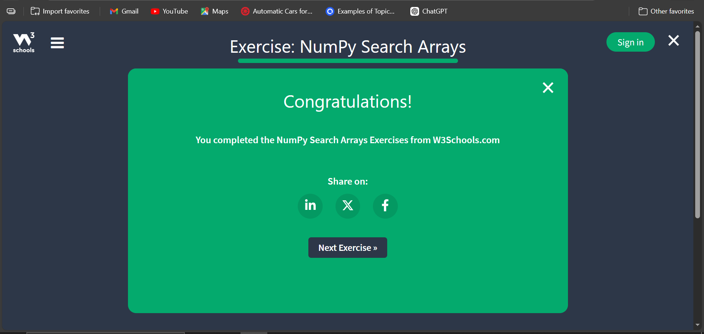

- Task 39 (NumPy Sort Arrays):

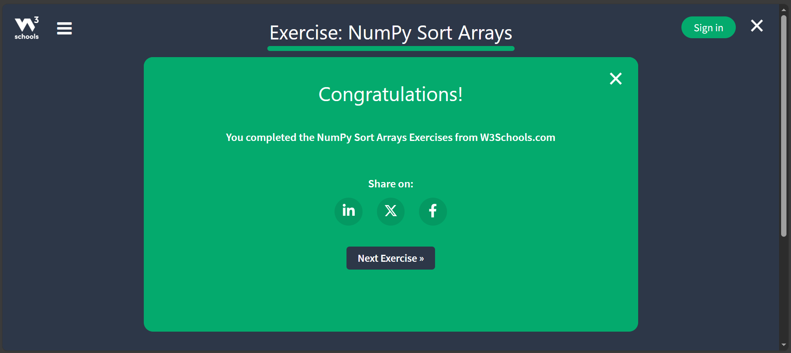

- Task 40 (NumPy Random Number):

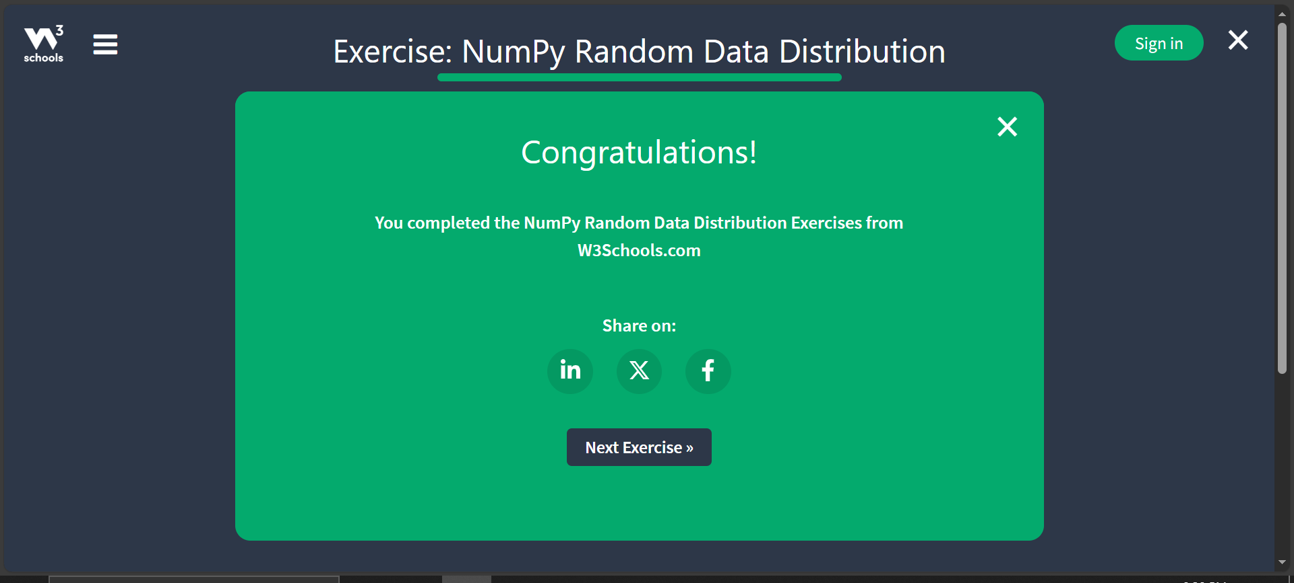

- Task 41 (Pandas Introduction):

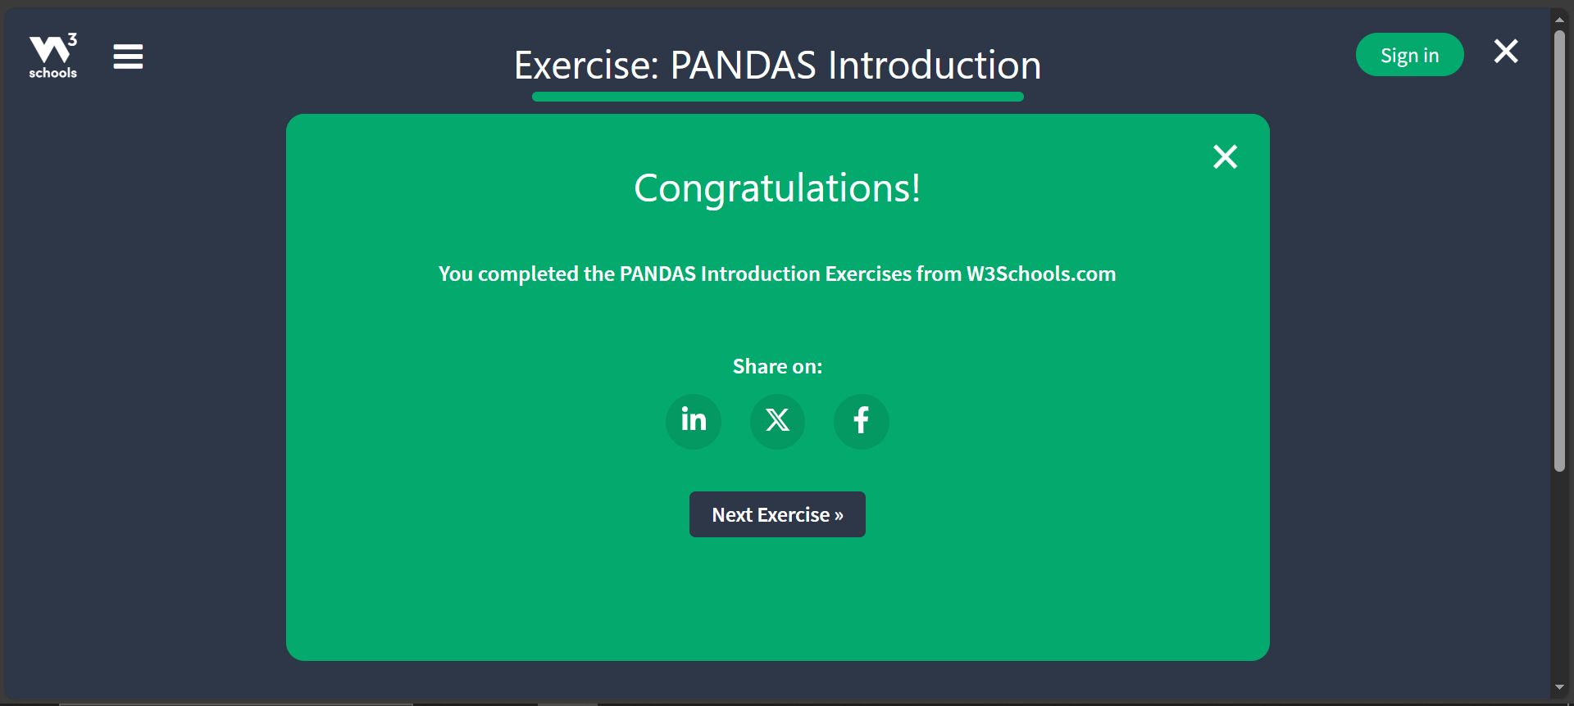

- Task 42 (Pandas Getting Started):

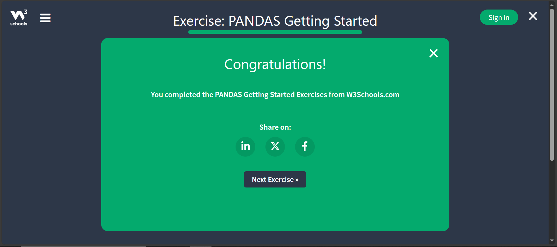

- Task 43 (Pandas Series):

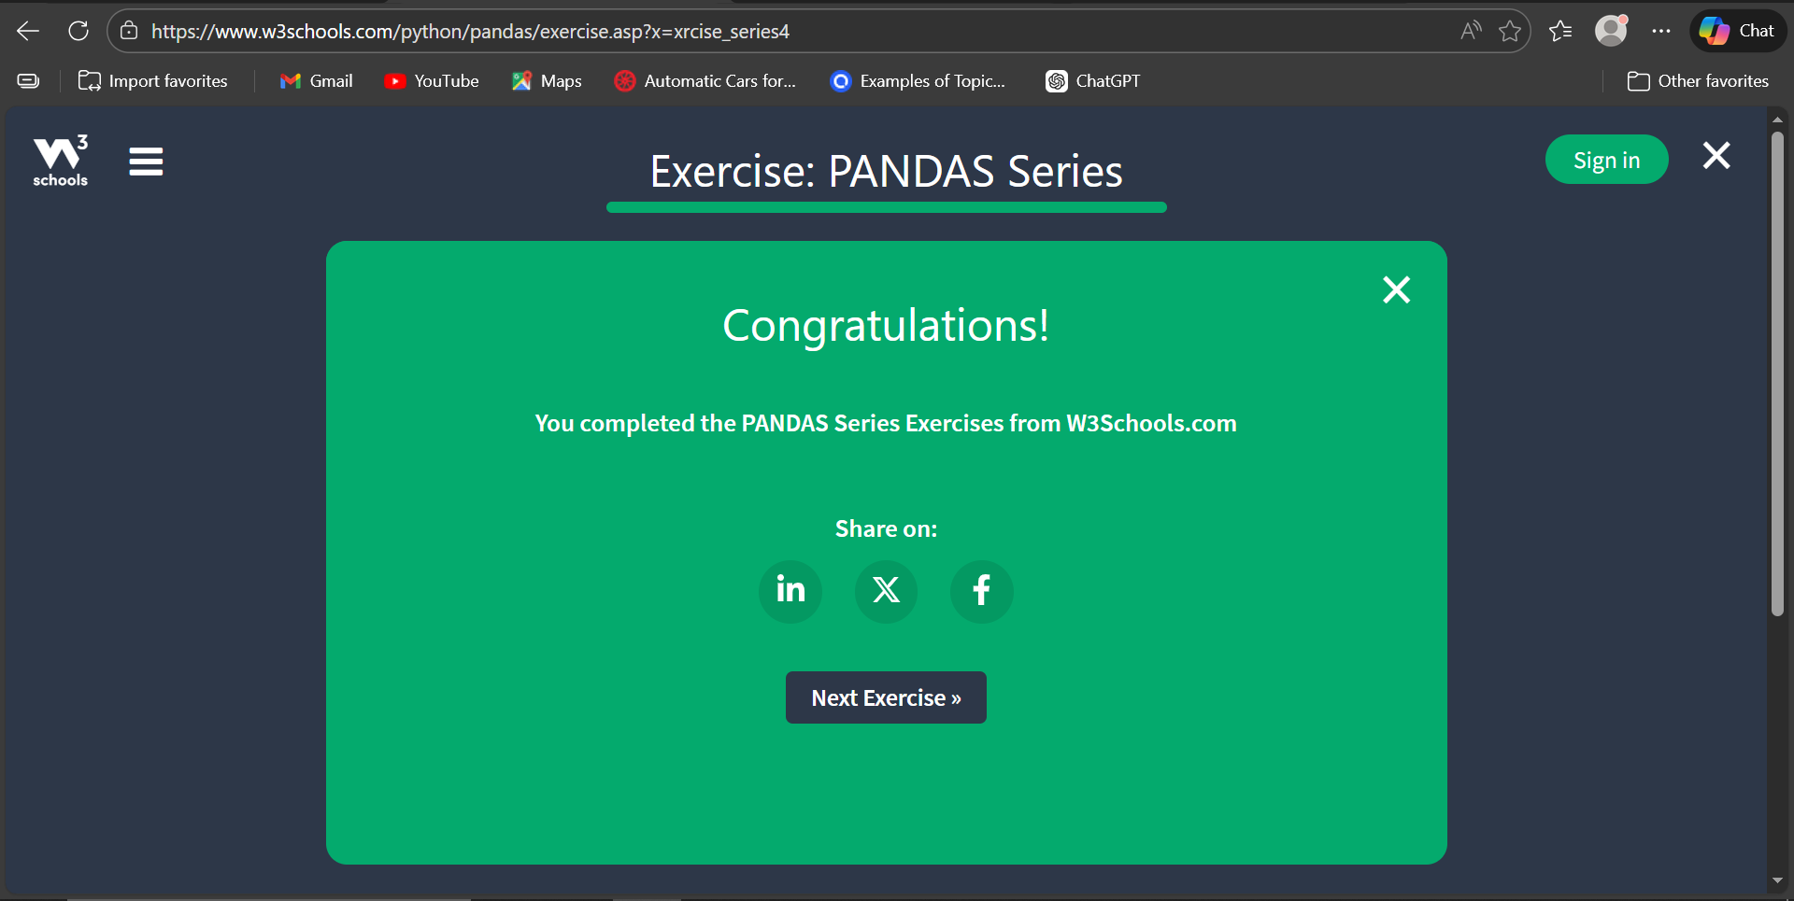

- Task 44 (Pandas DataFrames):

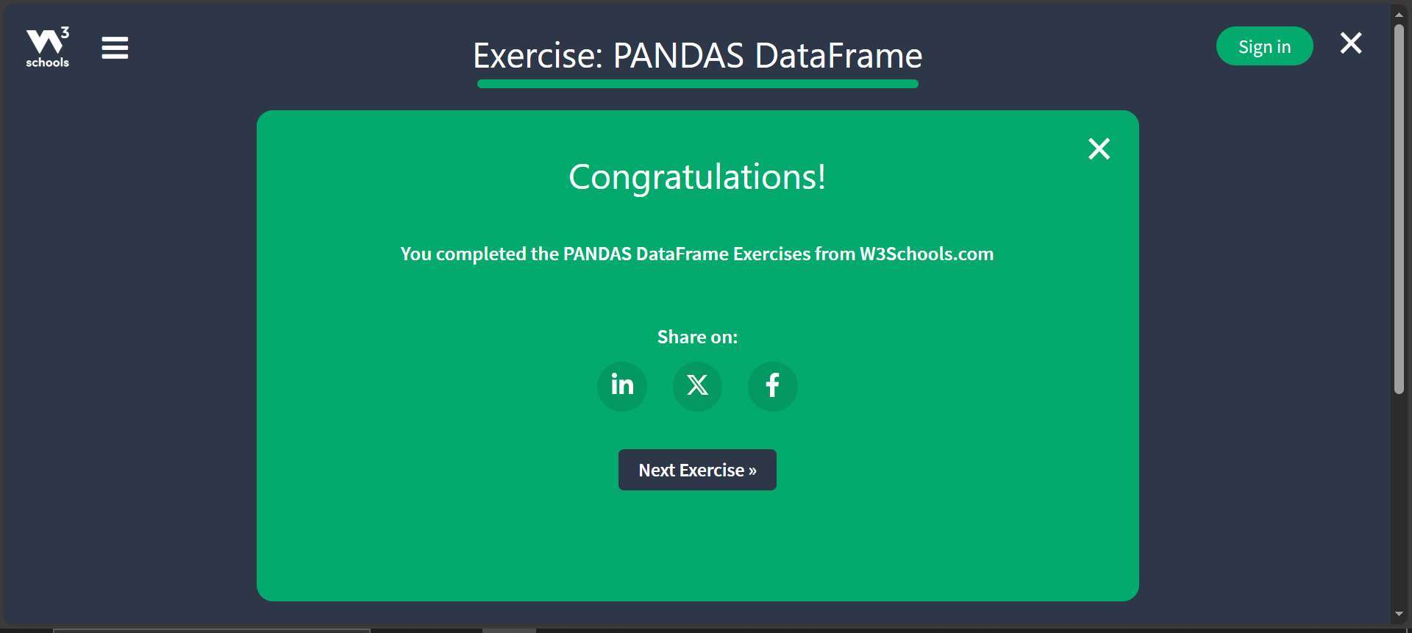

- Task 45 (Pandas Read CSV):

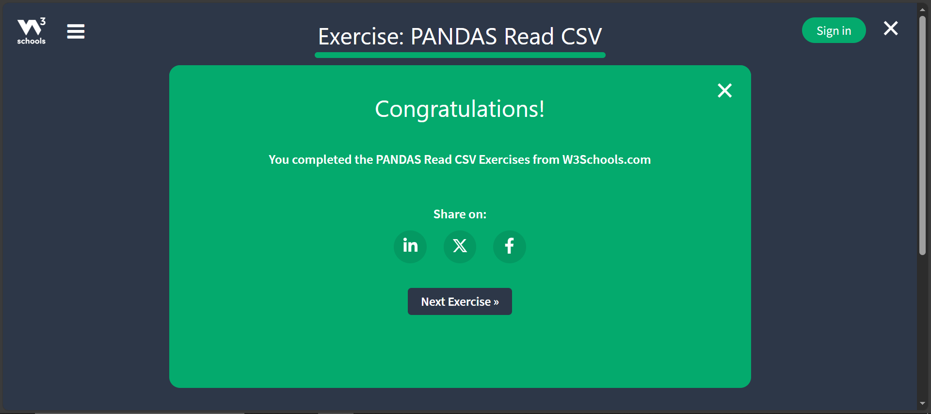

- TASK 46 (PANDAS Analyzing DataFrames):

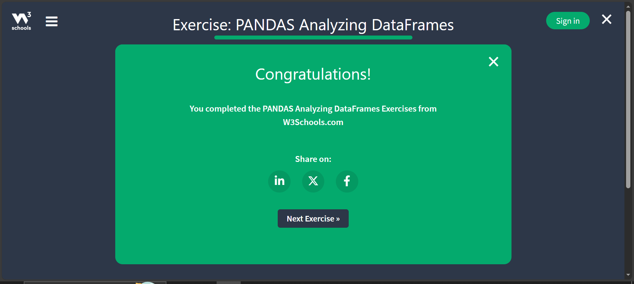

- TASK 47 (PANDAS Data Cleaning):
  - Cleaning Empty Cells:

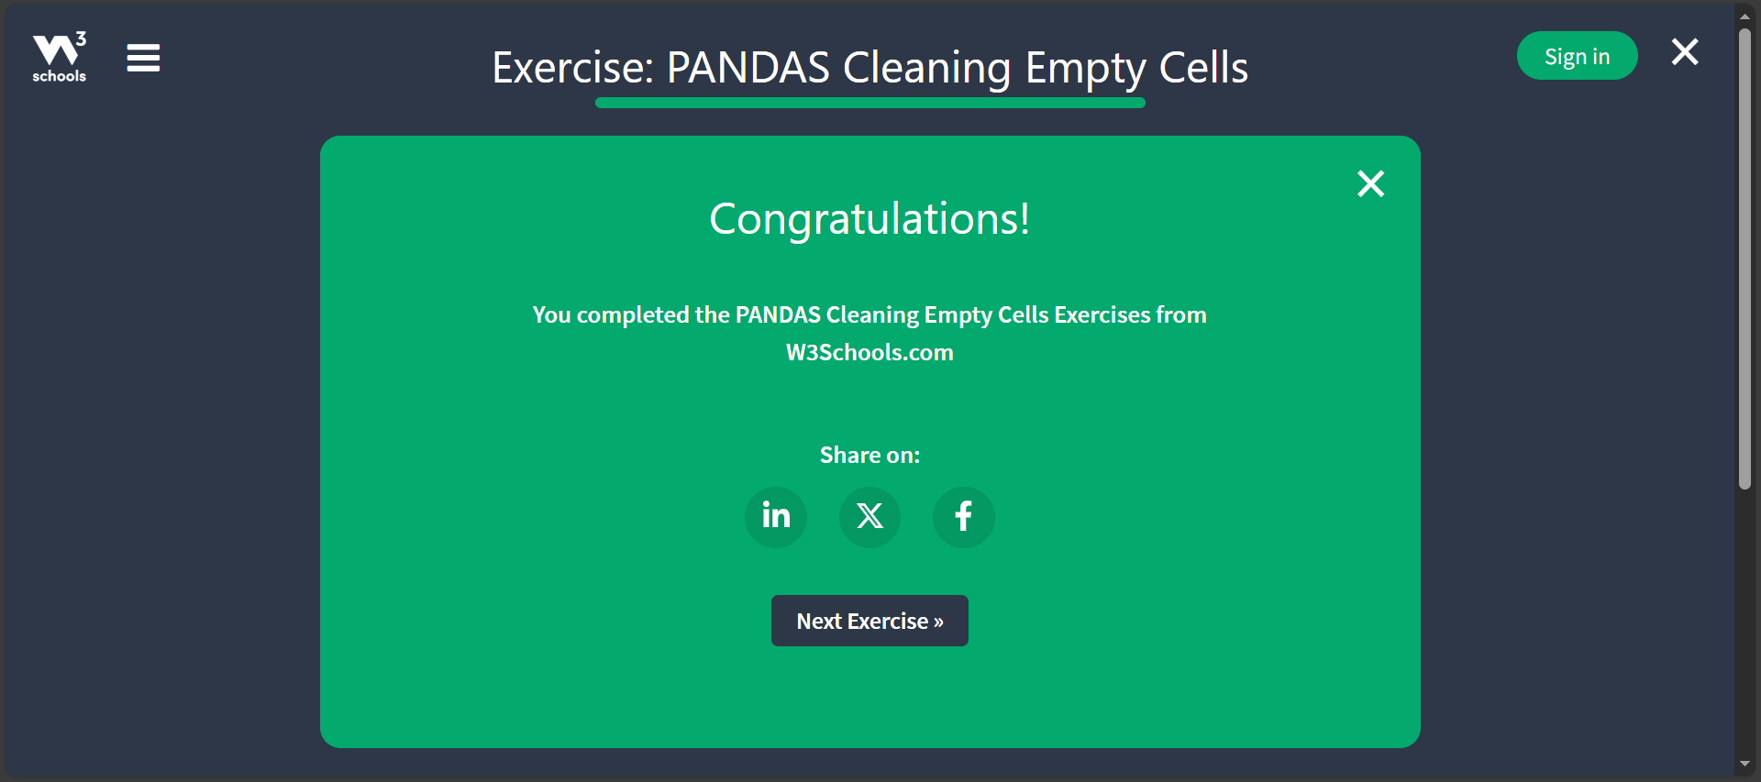

  - Cleaning Wrong Formats:

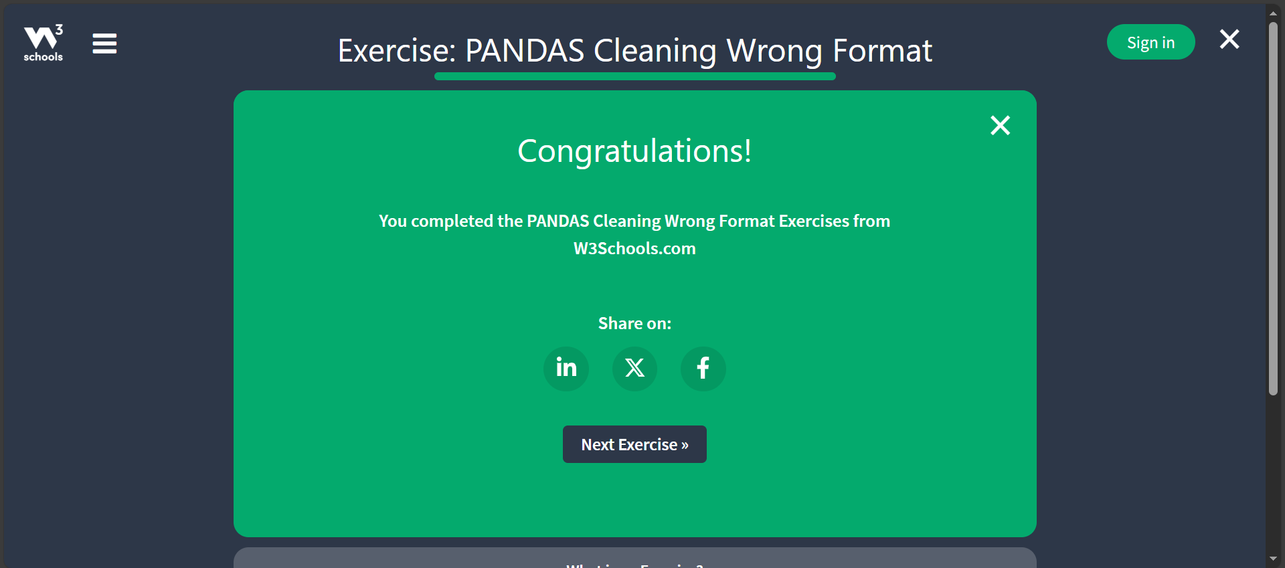

  - Cleaning Wrong Data:

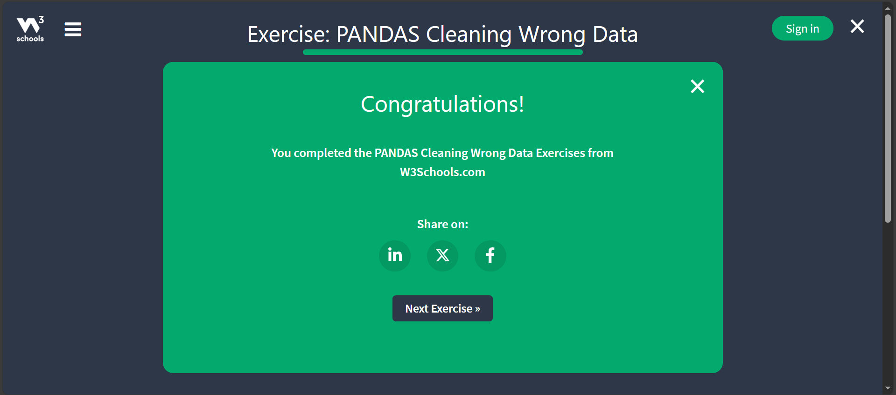

  - Cleaning Duplicates:

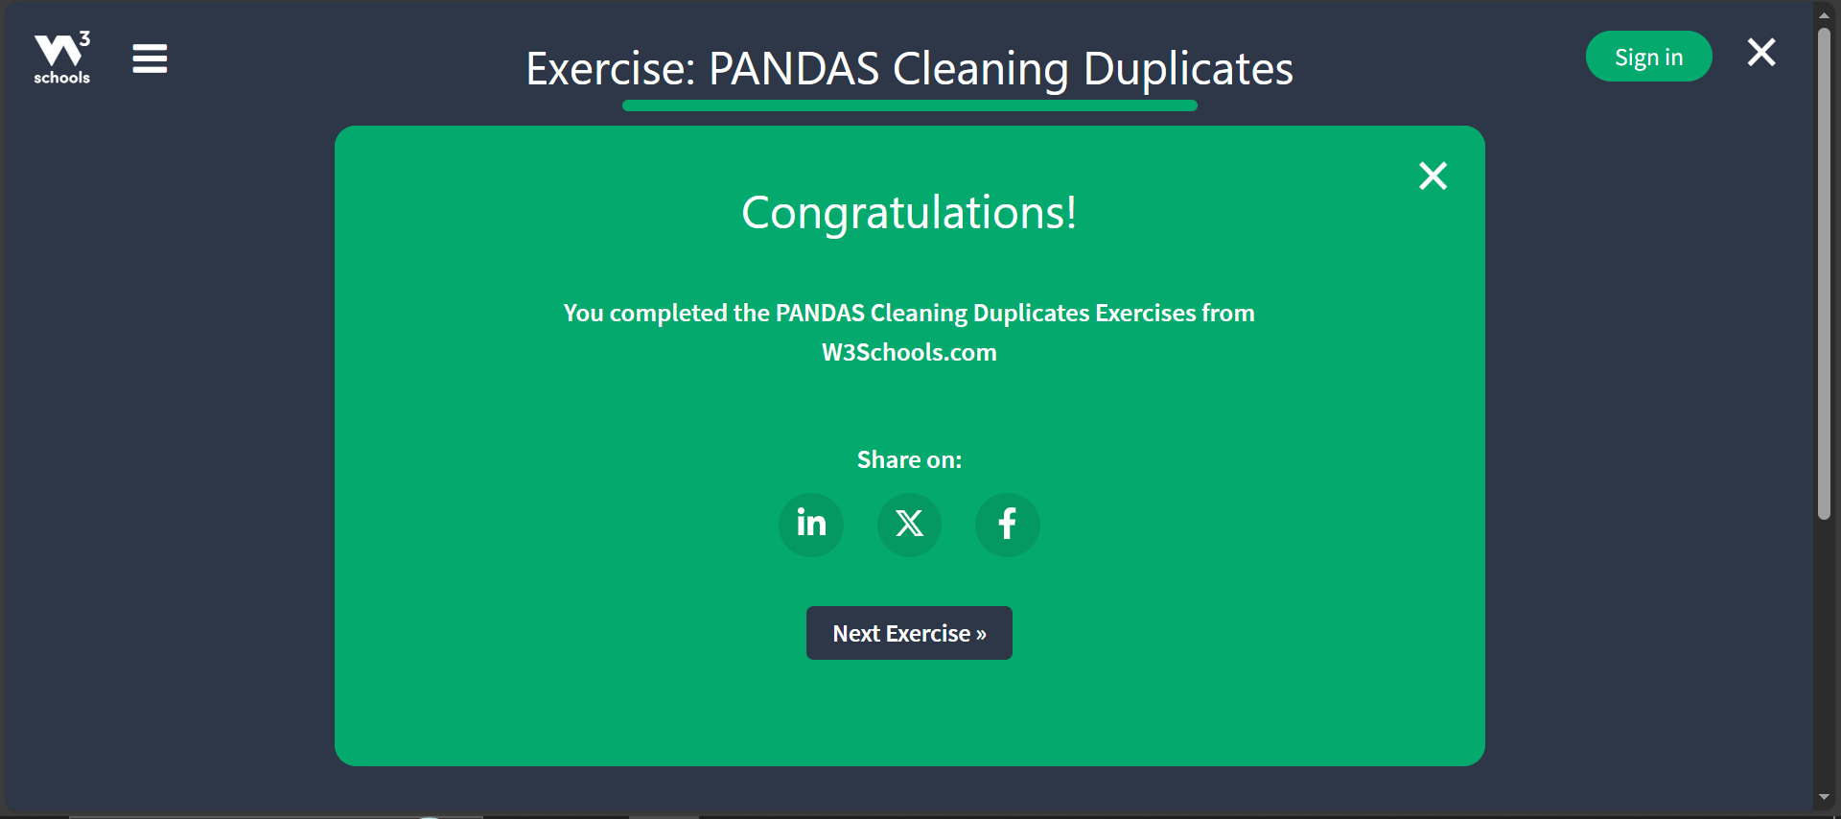

- TASK 48 (Pandas Correlation):

